JJC 2010 8872 Preliminary Examination Paper 2 (Worked Solutions)

1. | (a) | A gaseous mixture of ¹⁶O, ¹⁶O⁺ and ¹⁶O²⁻ is passed through an electric field which is at right angles to their direction of travel. Sketch and label, on the diagram below how each beam of the 3 particles is affected by the electric field.  +  –  ¹⁶O,  ¹⁶O⁺,  ¹⁶O²⁻ |  | [3]
 | (b) | P₄O₁₀(s) + 6H₂O(l) → 4H₃PO₄(aq)  SiO₂ has no reaction with water. |  | [2]
 | (c) | (i) | There is a sharp increase from 2nd to 3rd IE. The 3rd electron to be removed belongs to the inner quantum shell and requires a much greater energy to be removed.  ➔X has 2 valence electrons ➔ X is in Group II. | [4]
 |  | (ii) | 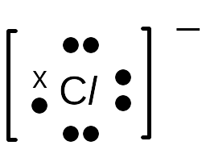  X
 |  | [Total: 9]

2. | (a) | Al  Cl  Cl  Cl  Cl  Cl  Cl  Al  Dative bond  Dative bond |  |  | [1]
 | (b) | Non-polar  Cl  Cl  Cl  Al  δ+  δ-  δ-  δ- |  |  | [2]
 | (c) | (i) | Acids are proton donors and bases are proton acceptors. |  | [3]
 |  | (ii) | Acid: [Al(H₂O)₆]³⁺  Conjugate base: [Al(OH)(H₂O)₅]²⁺  Base: H₂O  Conjugate acid: H₃O⁺
 | (d) | (i) | Al₂O₃ and HCl(aq),  Al₂O₃(s) + 6H⁺(aq) → 2Al³⁺(aq) + 3H₂O(l)  (or Al₂O₃(s) + 6HCl(aq) → 2AlCl₃(aq) + 3H₂O(l) ) |  | [2]
 |  | (ii) | Al₂O₃ and NaOH(aq)  Al₂O₃(s) + 2OH–(aq) + 3H₂O(l) → 2[Al(OH)₄]–(aq)  (or Al₂O₃(s) + 2NaOH(aq) + 3H₂O(l) → 2Na[Al(OH)₄](aq))
 |  |  | [Total: 8]

3. | (a) | 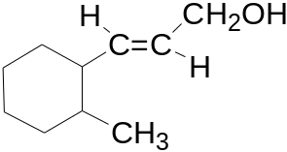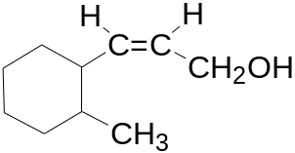  trans-isomer cis-isomer |  | [2]
 | (b) | (i) | 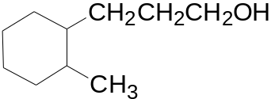 | [5]
 |  | (ii) | 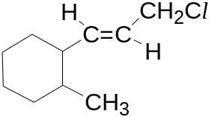  White fumes of HCl observed.
 |  | (iii) | 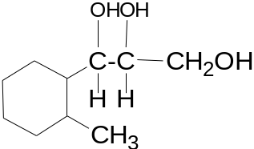  Purple KMnO₄ turns green, brown precipitate MnO₂ formed.
 | (c) | (i) | UV light, limited Cl₂ | [3]
 |  | (ii) | Oxidation
 |  | (iii) | 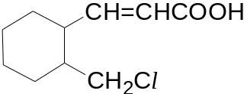
 |  |  | [Total: 10]

4. | (a) |  | Amount of heat gained by 200 cm³ of water  = 200 × 4.18 × (68.5 − 18.0) = 42218 J = 42.2 kJ  Mass of propane required = 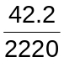 × 44.0 = 0.836 g |  |  |  | [2]
 | (b) |  | (i) |  | 3 C(g) + 8 H(g) + 10 O(g)  ΔH₁  +6460 kJ mol⁻¹  ΔH_{c}  C₃H₈(g) + 5O₂(g) 3CO₂(g) + 4H₂O(g)  ΔH₁ = 6E(C=O) + 8E(O−H) = 6 × 740 + 8 × 460 = + 8120 (kJ mol⁻¹) |  | [3]
 |  |  | (ii) |  | ΔH_{c} = +6460 − (+8120) = −1660 (kJ mol⁻¹)
 |  |  | (iii) |  | The bond energy values obtained from the Data Booklet are average (mean) bond energy values derived from a full range of molecules that contain the particular bond and would differ from the experimental values.
 | (c) |  | (i) |  | Total amount of heat energy released = 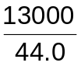× 2220 = 6.55 × 10⁵ kJ |  | [3]
 |  |  | (ii) |  | Total amount of time needed to empty one cylinder  = 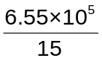= 4.37 × 10⁴ s  Rate at which propane must leave the container  = 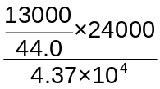= 162 cm³ s⁻¹  C  C  S  H  H  H  H  H  H
 | (d) |  | (i) |  | Bond angle around sulfur atom = 104.5° or 104° |  | [5]
 |  |  | (ii) |  | Ethanol has a higher boiling point than ethanethiol. More energy is needed to overcome the stronger hydrogen bonding between ethanol molecules than the weaker van der Waals’ forces between ethanethiol molecules.
 |  |  | (iii) |  | Minimum mass of ethanethiol required = 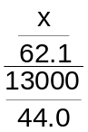× 10⁹ = 0.02  x = 3.67 × 10⁻⁷ g
 |  |  |  |  | [Total: 13]
5. |  | (a) |  | High reactivity with air : Na(s) + O₂(g) Na₂O(s)  High reactivity with water : Na(s) + H₂O(l) NaOH(aq) + ½H₂(g) |  |  |  | [2]
 |  | (b) |  | (i) |  | Sodium has giant metallic structure while chlorine has simple covalent/molecular structure.  Large amount of energy is required to overcome the strong metallic bond/electrostatic force of attraction between Na⁺ and delocalized electrons as compared to the weak van der Waals’/intermolecular force of attraction between chlorine molecules.  Hence, sodium has a higher melting point than chlorine.  Sodium has free mobile electrons as charged carrier to conduct electricity but chlorine does not have any mobile charged carrier.  Hence, sodium can conduct electricity in solid and liquid state but chlorine cannot conduct electricity in all physical state. |  | [6]
 |  |  |  | (ii) |  | 2Na(s) + Cl₂(g) 2NaCl(s)  Sodium reacts very vigorously with chlorine gas.
 |  |  |  | (iii) |  | Sodium chloride is an ionic chloride which dissolves in water to give a solution of pH 7.
 |  | (c) |  | (i) |  | 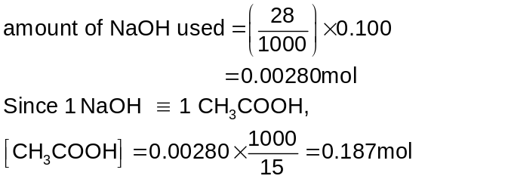 |  | [6]
 |  |  |  | (ii) |  | Phenolphthalein can be used as the indicator.  the pH of the solution at the equivalence point falls in the pH working range of the indicator.
 |  |  |  | (iii) |  | With acid : CH₃COO– + H⁺ CH₃COOH  With base : CH₃COOH + OH– CH₃COO– + H₂O
 |  | (d) |  | (i) |  | P : CH₃CH(OH)CH₃  Q : CH₃COO–Na⁺  R : CH₂=CHCH₃ |  | [6]
 |  |  |  | (ii) |  | I : nucleophilic substitution or alkaline hydrolysis  II : oxidation or triidomethane/iodoform test  III : elimination  IV : oxidation

6. | (a) | (i) | The standard enthalpy change of formation of a substance refers to the enthalpy change which occurs when one mole of substance is formed from its elements in their standard states under standard conditions. | [4]
 |  | (ii) | ΔH_{f}(CH₃CH₂OH(g)) − 52.3 + 242 = −46  ΔH_{f}(CH₃CH₂OH(g)) = −236 kJ mol⁻¹
 |  | (iii) | Enthalpy change = −236 − (−248) = +12 kJ mol⁻¹
 | (b) | (i) | K_{c} = 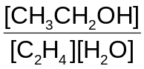 | [7]
 |  | (ii) | C₂H₄(g) + H₂O(g)  CH₃CH₂OH(g)  Initial amount/mol 1 3 −  (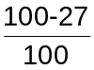×1)  = 0.73  Equilibrium amount/mol  3 − 0.27  = 2.73  0.27  K_{c} = = 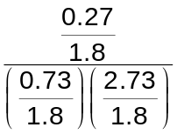= 0.243
 |  | (iii) | As temperature increases, the percentage of ethene converted decreases.  This shows that equilibrium position has shifted to the left to favour the endothermic backward reaction so as to remove some heat.  As pressure increases, the percentage of ethene converted increases.  This shows that equilibrium position has shifted to the right to produce less gaseous molecules so as to decrease the pressure.
6. | (c)  C  OH  CH₃  CH₃  H₃C  A  CH₃COCH₂CH₃  D | A does not undergo oxidation with acidified KMnO₄.  ⇒ A is a tertiary alcohol.  B and C undergo oxidation with acidified KMnO₄.  ⇒ B and C are either primary or secondary alcohols.  D undergoes condensation with 2,4-dinitrophenylhydrazine while E does not  ⇒ D is a ketone.  ⇒ B is a secondary alcohol.  ⇒ C is a primary alcohol.  ⇒ E is a carboxylic acid.  A and B undergoes elimination/ dehydration to give the same alkene.  C  H  CH₂OH  CH₃  H₃C  C  CH₃CH(OH)CH₂CH₃  B  C  H  COOH  CH₃  H₃C  E  C  CH₂  CH₃  H₃C  F |  | [9]

7 | (a) | (i) | G .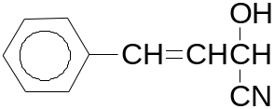 | [5]
 |  | (ii) | Step I: HCN, trace amount of base  Step II: dilute HCl, heat under reflux
 |  | (iii) | Add PCl₅.  Compound H will give white fumes of HCl, but cinnamadehyde will not.
 | (b) | (i) | oxidation number of S in SO₂ : +4  oxidation number of S in SO₄²⁻ : +6 | [5]
 |  | (ii) | Amount of Cr³⁺(aq) = 0.120 x 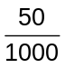= 6 x 10⁻³ mol  Since 3SO₂ ≡ 2Cr³⁺,  Amount of SO₂ dissolved = x 6 x 10⁻³ = 9 x 10⁻³ mol
 |  | (iii) | Orange dichromate(VI) solution turns green.
 | (c) | (i) | Concentration of vanillin may be followed by measuring the colour intensity of vanillin. | [10]
 |  | (ii) | Using the graph [HCN] = 5.00 mol dm⁻³, (t_{1/2})₁ = (t_{1/2})₂ = 0.095 min  Since half-lives is constant, it is 1st order with respect to vanillin.
 |  | (iii) | When the concentration of HCN increased by 50 times (from 0.1 mol dm⁻³ to 5.00 mol dm⁻³), half life decreased by 50 times/ rate of reaction increased by 50 times. Order of reaction with respect to HCN is one.
 |  | (iii) | Rate = k[vanillin][HCN] Units for k = mol⁻¹dm³min⁻¹
 |  | (iv) | A catalyst provides an alternative reaction path of lower activation energy than that of the uncatalysed reaction.  In the presence of a catalyst, the number of molecules with energy ≥/> E_{a}’, increases.  Therefore, the frequency of effective collisions between these reactant molecules increases and hence, the reaction rate increases.  No. of particles with energy ≥/> E_{a}’  No. of particles with energy ≥/> E_{a}  E_{a}’  E_{a}  Energy  Fraction of molecules  0  E_{a:} activation energy for uncatalysed rxn  E_{a}’ : activation energy for catalysed rxn

